**PROJECT INFORMATION**

|  |  |  |  |
| --- | --- | --- | --- |
| **Project acronym** | CFS | | |
| **Project Title** | Coffee Shop | | |
| **Start Date** |  | **End Date** |  |
| **Lead Institution** | International School, Duy Tan University | | |
| **Project Mentor** | MSc Huy, Truong Dinh | | |
| **Scrum master / Project Leader & contact details** | Kiet, Nguyen Tuan  Email:  Tel: | | |
| **Partner Organization** | Duy Tan University | | |
| **Project Web URL** |  | | |
| **Team members** | Name | Email | Tel |
|  | Kiet,Nguyen Tuan |  |  |
|  | Duc,Tran Van |  |  |
|  | Diem, Dinh Thi Kim |  |  |
|  | Khai, Nguyen Van |  |  |
|  |  |  |  |

REVISION HISTORY

| **Version** | **Date** | **Comments** | **Author** |
| --- | --- | --- | --- |
| 1.0 | July 6th, 2024 | Initial Release | C1SE05 Team |
| 1.1 | July13th, 2024 | Update Current Status of Art | C1CE05 Team |

**TABLE OF CONTENT**

1. Introduction 1

1.1. Purpose 1

1.2. Scope 1

2. Interface Design 1

2.1. Home page 1

2.2. Navbar 2

2.3. Course 3

2.3.1. Free course 3

2.3.2. Fee course 4

2.3.3. Payment the course 4

# 1. Introduction

# 1.1. Purpose

This specification covers following:

* Documentation helps to better understand the user interface of the website, the detailed description and functionality of the website.
* With this documentation, the development team can understand the structure and composition details to create a consistent and complete system.

# 1.2. Scope

* Overview of the stages and modules of the software.

- Create complete interface and describe them clearly.

# 2. Interface Design 2.1. Home page

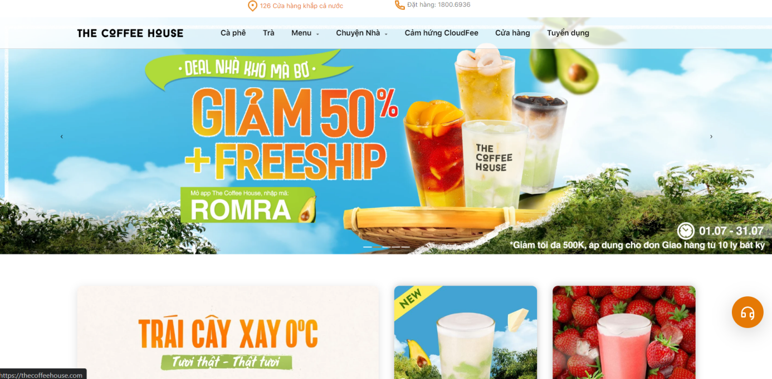

Figure 1: homepage interface

|  |  |  |  |  |
| --- | --- | --- | --- | --- |
| **Homepage** | | | | |
| **No.** | **Field name** | **Type** | **Require** | **Target** |
| 1 | Background |  | green |  |
| 2 | Menu | Grid View | Heading: h2 tag  Font-size: 20px color:  Button: members | list of courses you have taken |

# 2.2. Navbar



Figure 2: Navbar interface

|  |  |  |  |  |
| --- | --- | --- | --- | --- |
| **Navbar** | | | | |
| **No.** | **Field name** | **Type** | **Require** | **Target** |
| 1 | menu | p2 | color: #000000  Font: 16px |  |
| 2 | Cửa hàng | List | color: #000000  Font: 16px |  |

# 2.3. Course

# 2.3.1. Cafe

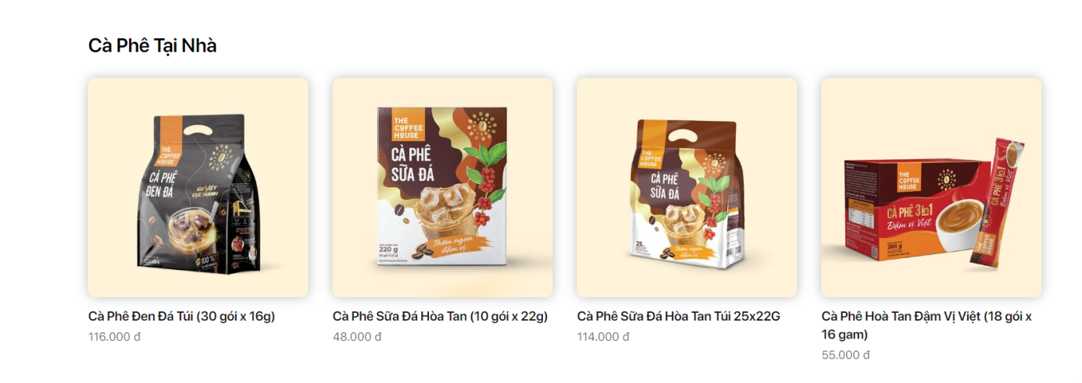

Figure 3: Free course interface

|  |  |  |  |  |
| --- | --- | --- | --- | --- |
| **Topic** | | | | |
| **No.** | **Field name** | **Type** | **Require** | **Target** |
| 1 | Heading | p | Font-size: 24px  color: #000000 | Topic |
| 2 | Toping | image | Image topic: 382x250 |  |

# 2.3.2. Shop

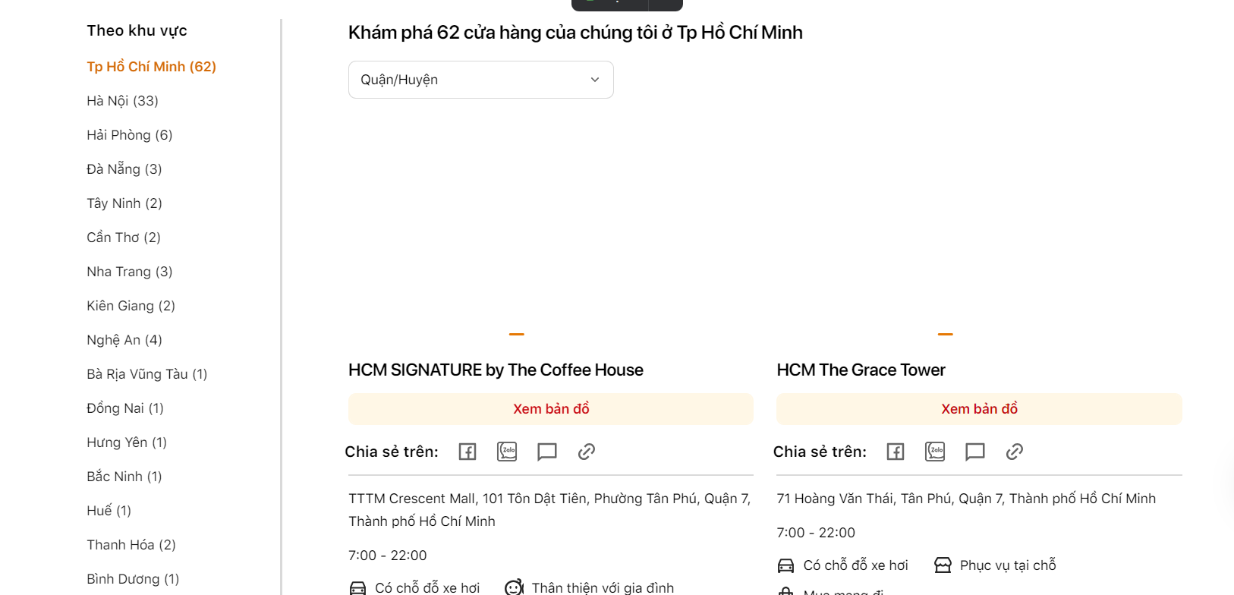

Figure 4:Shop interface

|  |  |  |  |  |
| --- | --- | --- | --- | --- |
| **Group of topic** | | | | |
| **No.** | **Field name** | **Type** | **Require** | **Target** |
| 1 | Heading | p | Font-size: 24px | Topic |
| 2 | Topic | image | Image  Background: green  382x250 |  |

# 2.3.3. Payment the coffee

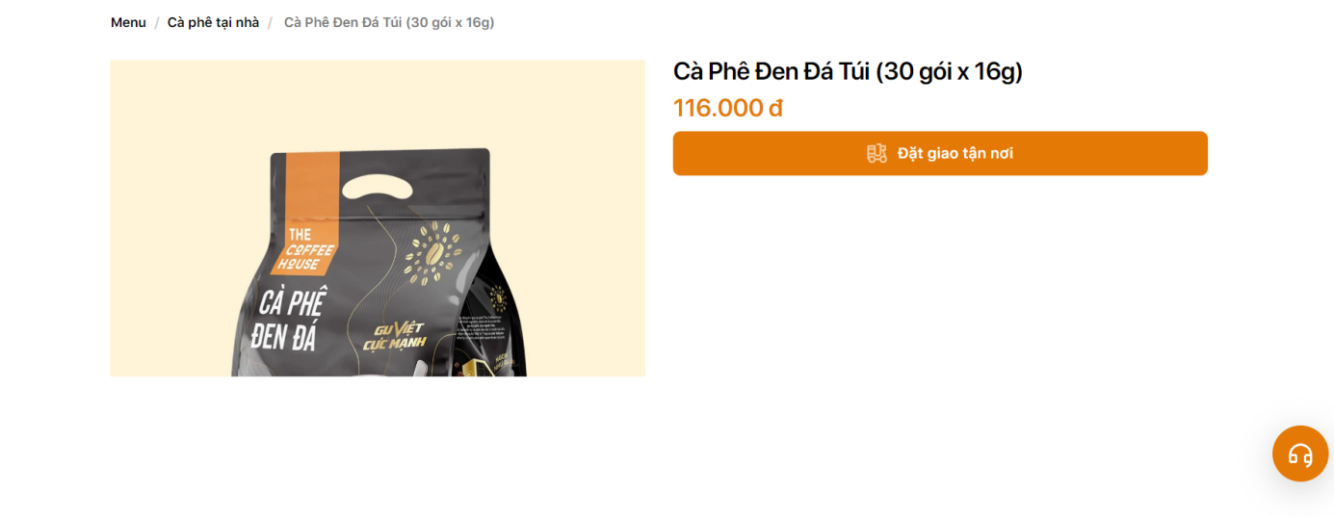

Figure 5: Payment notification interface

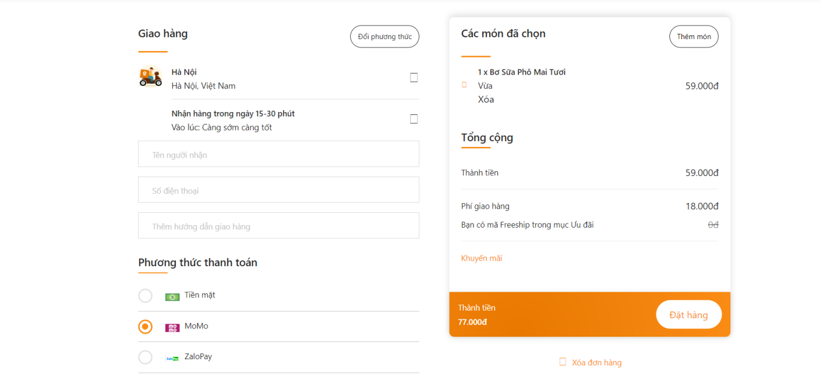

Figure 6: Payment VNPAY interface

|  |  |  |  |  |
| --- | --- | --- | --- | --- |
| **Detail group** | | | | |
| **No.** | **Field name** | **Type** | **Require** | **Target** |
| 1 | text | Button | color: #FFFFFF  background: #1D4ED8  padding: 10px 20px |  |
| 2 | Topic | function |  | payment |